**Code Smell – 1**

**Data Class**

This code smell occurs when the class is too small. These classes only have getter and setter methods and no real funcionalities.

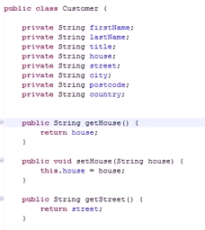**Code Snippet:**

**Code Location:**

The classe is in the folloying path:

“*src-gen\main\java\org\jabref\logic\importer\fileformat\medline\NameOfSubstance.java*”

A new class is created with two instance variables:

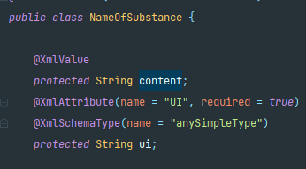

The class only have four methods (getters and setters):

   

**Justification:**

As shown in the images, the class NameOfSubstance have nothing more than two instance variables and respective getters and setters.

**Refactoring proposal:**

This code smell may indicate that this is not a necessary class. We have two solutions: try to complete the class with real functionalaties (if there’s any funcionality to add) or only manipulate the data in the classes that use it.